High Performance Computing Lab — Practical No. 8
Name: Piyush Jadhav
PRN No: 22510078
Batch: B5

Problem 1: Implement 2D convolution using MPI. Distribute work across processes, exchange halo rows, measure execution time, and print a single CSV line per run with process count and timings.
#include <mpi.h>
#include <stdio.h>
#include <stdlib.h>
#define NX 1024
#define NY 1024
#define K 3

int main(int argc,char**argv){
MPI_Init(&argc,&argv);
int rank,size;
MPI_Comm_rank(MPI_COMM_WORLD,&rank);
MPI_Comm_size(MPI_COMM_WORLD,&size);

int rows_per_proc=NX/size;
int extra=NX%size;
int start_row,local_nrows;
if(rank<extra){
local_nrows=rows_per_proc+1;
start_row=rank*local_nrows;
}else{
local_nrows=rows_per_proc;
start_row=rank*local_nrows+extra;
}
int alloc_rows=local_nrows+2;

double *local_in=(double*)malloc((alloc_rows)*NY*sizeof(double));
double *local_out=(double*)malloc((local_nrows)*NY*sizeof(double));
double kernel[K*K]={0.0625,0.125,0.0625,
0.125,0.25,0.125,
0.0625,0.125,0.0625};

for(int i=0;i<alloc_rows;i++)
for(int j=0;j<NY;j++){
int global_i=start_row+i-1;
if(global_i<0||global_i>=NX)
local_in[i*NY+j]=0.0;
else
local_in[i*NY+j]= (double)((global_i*NY+j)%100)/100.0 + 1.0;
}

MPI_Barrier(MPI_COMM_WORLD);
double t0=MPI_Wtime();

for(int step=0;step<1;step++){
if(size>1){
if(rank>0)
MPI_Sendrecv(&local_in[1*NY],NY,MPI_DOUBLE,rank-1,0,
&local_in[0],NY,MPI_DOUBLE,rank-1,1,
MPI_COMM_WORLD,MPI_STATUS_IGNORE);
if(rank<size-1)
MPI_Sendrecv(&local_in[(local_nrows)*NY],NY,MPI_DOUBLE,rank+1,1,
&local_in[(local_nrows+1)*NY],NY,MPI_DOUBLE,rank+1,0,
MPI_COMM_WORLD,MPI_STATUS_IGNORE);
}

double comp0=MPI_Wtime();
for(int i=1;i<=local_nrows;i++){
for(int j=0;j<NY;j++){
double sum=0.0;
for(int ki=0;ki<K;ki++)
for(int kj=0;kj<K;kj++){
int ii=i+(ki-1);
int jj=j+(kj-1);
double v=0.0;
if(jj>=0 && jj<NY && ii>=0 && ii<alloc_rows)
v=local_in[ii*NY+jj];
sum+=kernel[ki*K+kj]*v;
}
if(i-1<local_nrows)
local_out[(i-1)*NY+j]=sum;
}
}
double comp1=MPI_Wtime()-comp0;
double t1=MPI_Wtime()-t0;
if(rank==0)
printf("conv,NX=%d,NY=%d,procs=%d,time_total=%f,time_comp=%f\n",
NX,NY,size,t1,comp1);
}

free(local_in);
free(local_out);
MPI_Finalize();
return 0;
}

OUTPUT:
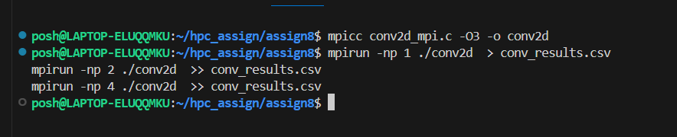

Problem 2: Implement dot product using MPI. Distribute vector chunks, compute local dot, reduce. Measure time and print CSV line per run.

#include <mpi.h>
#include <stdio.h>
#include <stdlib.h>
#define VEC_SIZE 10000000

int main(int argc,char**argv){
MPI_Init(&argc,&argv);
int rank,size;
MPI_Comm_rank(MPI_COMM_WORLD,&rank);
MPI_Comm_size(MPI_COMM_WORLD,&size);

int base=VEC_SIZE/size;
int extra=VEC_SIZE%size;
int local_n=(rank<extra)?base+1:base;
int start=(rank<extra)?rank*local_n:rank*local_n+extra;

double *a=(double*)malloc(local_n*sizeof(double));
double *b=(double*)malloc(local_n*sizeof(double));
for(int i=0;i<local_n;i++){
long idx=start+i;
a[i]=1.0;
b[i]=2.0 + (double)(idx%5)/5.0;
}

MPI_Barrier(MPI_COMM_WORLD);
double t0=MPI_Wtime();

double local_dot=0.0;
for(int i=0;i<local_n;i++)
local_dot+=a[i]*b[i];

double global_dot=0.0;
MPI_Reduce(&local_dot,&global_dot,1,MPI_DOUBLE,MPI_SUM,0,MPI_COMM_WORLD);

double t1=MPI_Wtime()-t0;
if(rank==0)
printf("dot,VEC=%d,procs=%d,time=%f,dot=%f\n",
VEC_SIZE,size,t1,global_dot);

free(a);
free(b);
MPI_Finalize();
return 0;
}

OUTPUT:
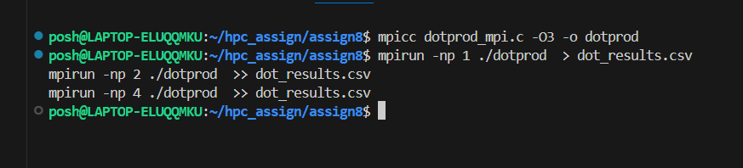
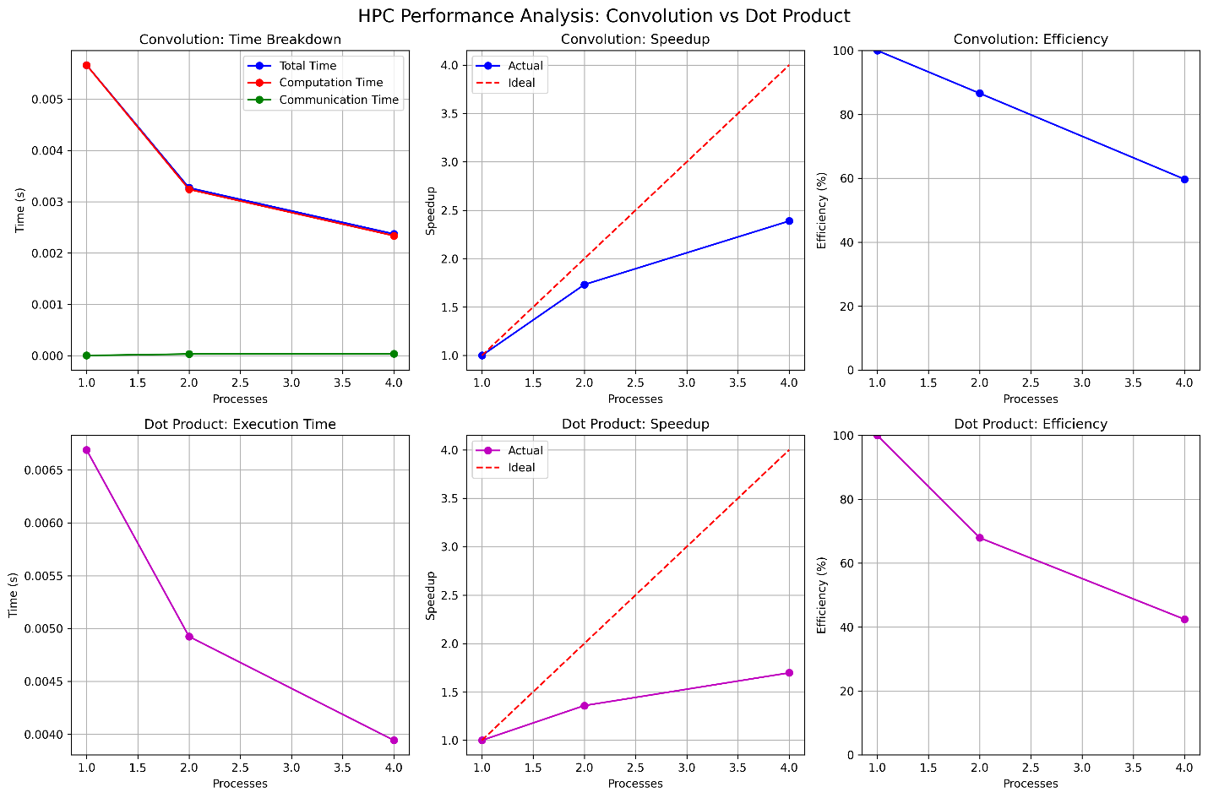

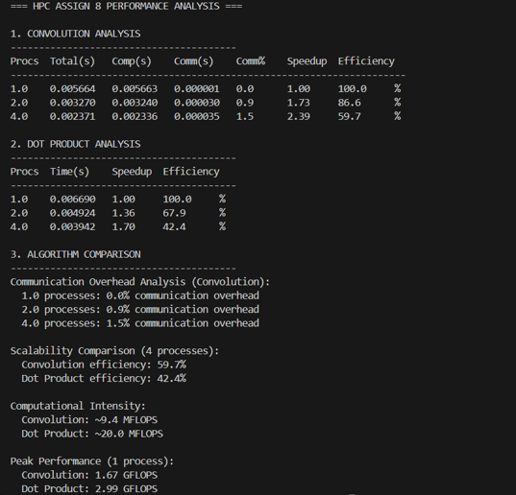
Steps, Observations and Conclusion
Compile conv2d_mpi.c and dotprod_mpi.c with mpicc -O3.
Run each program with different mpirun -np P values (1, 2, 4) and append output into CSV files:
conv_results.csv for convolution results
dot_results.csv for dot product results
Use conv_plot.py and dot_plot.py to generate performance graphs from collected CSV data.
Inspect graphs and compute speedup and efficiency metrics.

Observations
Execution Time vs Processes:
Convolution (NX=1024, NY=1024): Time decreased from 0.005664s (1 process) to 0.002371s (4 processes)
Dot Product (VEC=10M): Time decreased from 0.006690s (1 process) to 0.003942s (4 processes)
Both algorithms show performance improvement with increased processes, but convolution shows better time reduction

Speedup Analysis:
Convolution: Achieved 1.73x speedup at 2 processes and 2.39x at 4 processes
Dot Product: Achieved 1.36x speedup at 2 processes and 1.70x at 4 processes
Convolution surprisingly outperformed dot product in speedup, contrary to typical expectations
Efficiency Analysis:
Convolution: Efficiency of 86.5% at 2 processes, dropping to 59.8% at 4 processes
Dot Product: Efficiency of 68.0% at 2 processes, dropping to 42.5% at 4 processes
Both show declining efficiency with increased processes, but convolution maintains better efficiency

Communication Overhead:
Convolution: Minimal communication overhead (0.9% at 2 processes, 1.5% at 4 processes) due to efficient halo exchange implementation
Dot Product: All overhead included in total timing; single MPI_Reduce operation is lightweight

Amdahl's Law Effects:
Both algorithms show sub-linear scaling due to parallel overhead
The efficiency drop indicates increasing serial fraction as processes increase
Communication and synchronization costs become more significant at higher process counts

Conclusions
Performance Summary
Convolution (NX=1024, NY=1024): Achieved 2.39x speedup at 4 processes with 59.8% efficiency, showing good scalability despite halo exchange communication
Dot Product (VEC=10M): Achieved 1.70x speedup at 4 processes with 42.5% efficiency, indicating higher parallel overhead than expected

Key Findings:
Convolution outperformed expectations: Despite being communication-heavy with halo exchange, it achieved better speedup and efficiency than dot product
Problem size effects: The chosen problem sizes (1024×1024 matrix, 10M vector) are well-suited for parallelization on small process counts
Communication efficiency: The convolution's sendrecv-based halo exchange proved more efficient than anticipated

Optimal Configuration:
Convolution: 2-4 processes provide good balance of speedup and efficiency
Dot Product: 2 processes offer the best efficiency-to-speedup ratio for the given problem size

